CREATIVE EDUCATIONAL SERVICES
END OF TERM TWO EXAMINATIONS 2024
PRIMARY TWO

RELIGIOUS EDUCATION

Name ________________________________________________ Stream _____________
Date _________________________________________________

- (a) Who is the creator of earth and heaven?
___________________________________________________________
(b) Draw and name any one God’s creation in the sky.
(c) Which book in the Bible talks about God’s creation?
___________________________________________________________
- (a) Who is your neighbour according to Jesus?
___________________________________________________________
(b) Name any two groups of people in need.
(i) _________________________________________________________
(ii)_________________________________________________________
(c) Mention any one way of caring for the needy.
___________________________________________________________

- (a) What is a family?
___________________________________________________________
(b) Write any two members of God’s family.
(i) _________________________________________________________
(ii)_________________________________________________________
(c) How can one become a member of God’s family?
___________________________________________________________
- (a) Who was the father of Cain and Abel in the Bible?
___________________________________________________________
(b) How did God punish Adam?
___________________________________________________________
(c) Name the garden where Adam and Eve lived.
___________________________________________________________
- (a) Identify any two places where people worship God from.
- ______________________________________________________
- ______________________________________________________
(b) Write any two ways of worshiping God.
(i) ______________________________________________________
(ii) ______________________________________________________
(c) When do we pray to God?
___________________________________________________________

- (a) Name these religious symbols.
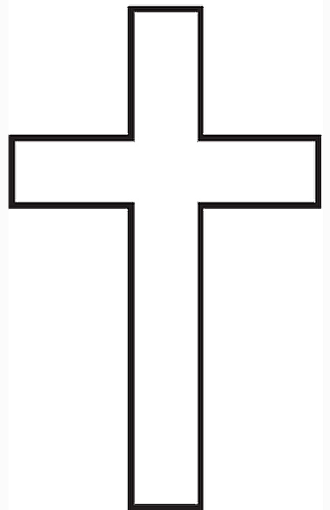 | 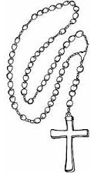 | 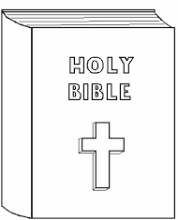
(b) Why do we need pastors in churches?
___________________________________________________________
- (a) Name any two Christian names for girls.
- ______________________________________________________
- ______________________________________________________
(b) Name any two disciples of Jesus.
(i) ______________________________________________________
(ii) ______________________________________________________
(c) What is the meaning of these things according to the
Bible:-
- bread _______________________________________________
- wine _______________________________________________
- (a) How did Jesus show love and care to people?
- ______________________________________________________
- ______________________________________________________
(b) Write any two ways of showing respect to your parents.
(i) ______________________________________________________
(ii) ______________________________________________________

(c) On which day did Jesus die on the cross?
___________________________________________________________
- (a) Name one gift on your body.
___________________________________________________________
(b) Match the names correctly.
(i) Peter blessing
(ii) Emmanuel picked from water.
(iii) Moses God is with us.
(iv) Mukisa rock.

- Peter ___________________________________
- Emmanuel ___________________________________
- Moses ___________________________________
- Mukisa ___________________________________
- (a) Draw and name any two basic needs of a family.

(b) Who was the mother of Jesus?
___________________________________________________________

- (a) Mention any two books in the Bible.
- ______________________________________________________
- ______________________________________________________
(b) Name any two people found in a school.
(i) ______________________________________________________
(ii) ______________________________________________________
- (a) Apart from the Holy Spirit, give two other persons in the
Holy trinity.
- _____________________________________________________
- ______________________________________________________
(b) ___________________________ is the day when the Holy
spirit came upon the disciples in the upper room.
(Good Friday, Pentecost, Easter day)
- Who was the earthly father of Jesus Christ?
___________________________________________________________
END.

